|  |
| --- |
|  |
|  |

|  |  |  |  |  |  |
| --- | --- | --- | --- | --- | --- |
| REVISION HISTORY | | | | | |
| Ver. | Description of Change | Author | Date | Approved | |
| Name | Effective Date |
| 1.0 | Initial status | Olga_Hilko | 04-DEC-2017 |  |  |
|  |  |  |  |  |  |
|  |  |  |  |  |  |

Contents

1. FCTPayment 3

2. Grants 3

3. Packages 3

# FCTPayment

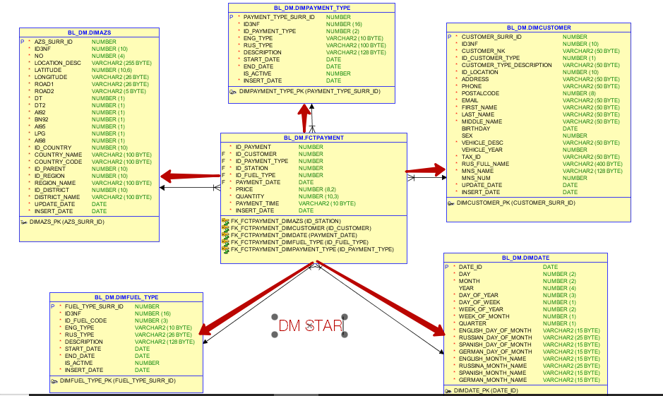

# Grants

exec FRAMEWORK.pkg_utl_grants_mgmt.proc_grant (' SELECT', 'BL_DM','FCTPAYMENT','FRAMEWORK');

exec FRAMEWORK.pkg_utl_grants_mgmt.proc_grant (' SELECT, INSERT, UPDATE, DELETE', 'BL_DM','FCTPAYMENT','BL_CL_DM');

# Packages

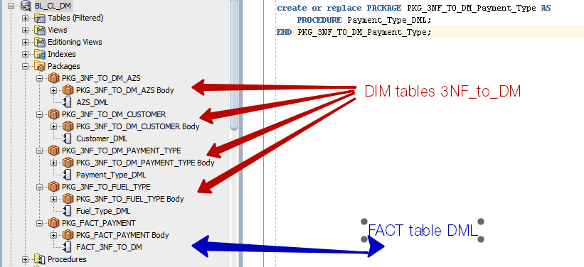

# Insert Data

row count before insert

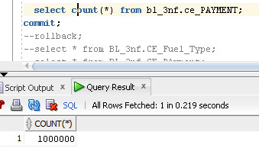

row count after insert

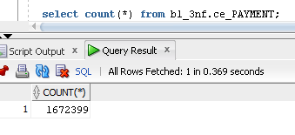

It was generated 1000000 rows, but after the new customers were pasted and commit was not applied sequence for 49990 new customers was generated. So, there are GAPs in Customer tables. Rows for not existed customers were deleted.